Volume 6 Number 5 _______ May 2020

FOOTHILLS PHOTOGRAPHY
GROUP
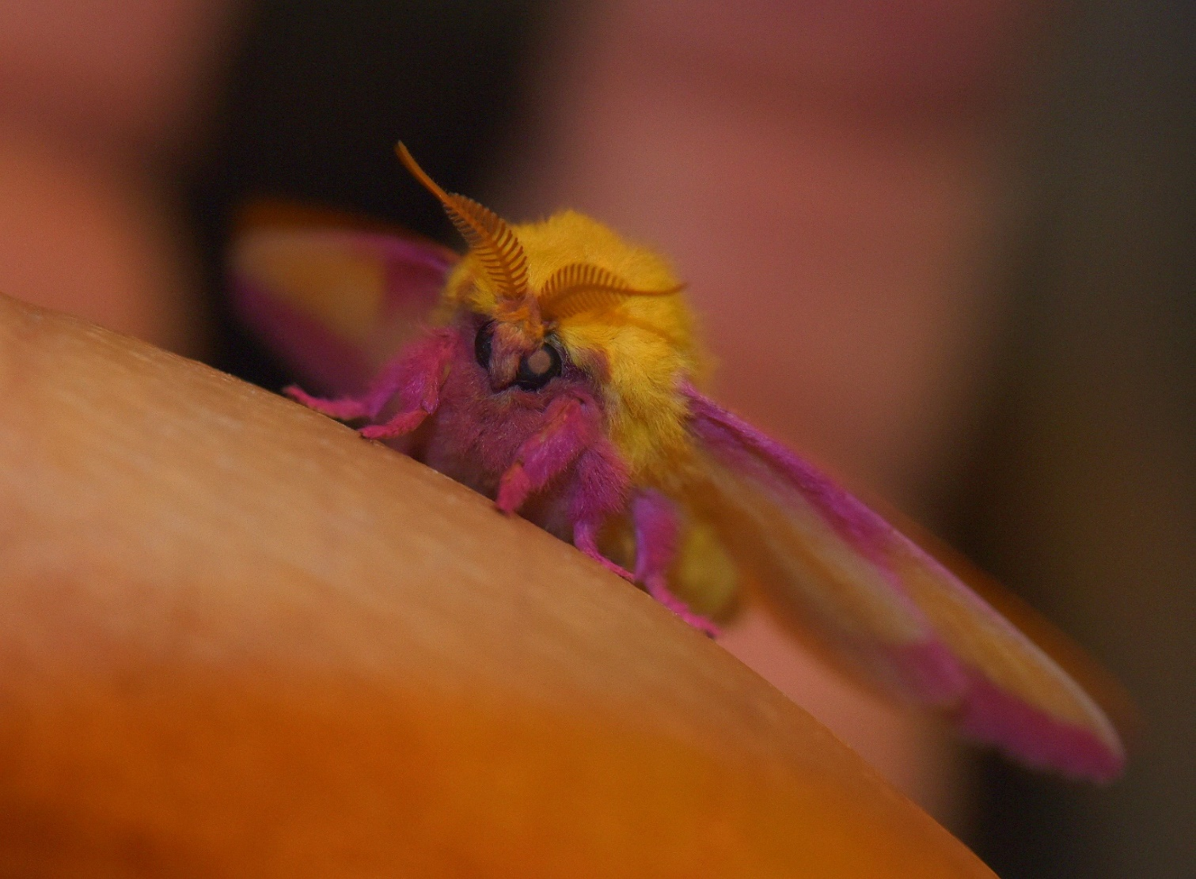

Monthly Newsletter

Spring Porch Light Visitor - Rosy Maple Moth by David Hinson

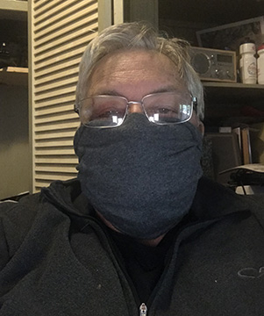
From our President.......

Fellow Club Members,

I hope this finds you and your families safe and well during The Great Pandemic of 2020. Our policy for club events or gatherings has not changed. Maintaining social distancing is of the upmost importance. The policy can be found in its entirety on the club web page. I hope you have been able to take some images of your own during the time we have all been at home.
Since the start of the quarantine I have taken about 4300 images. Out of those I have shared around 200 in various places.
In my defense, my wife is working from home, there are not any current sports on television, I'm not a binge TV watcher, (nothing is that interesting to me), and with my physical issues I am limited with things I can do around the house. So, I press the shutter until my finger is sore! If you are tired of seeing my images on Facebook, be grateful that I have only shared a little less than 5% of what I have taken.
Seriously though, photography is such a wonderful hobby. With today's digital cameras it literally cost me nothing to take, view, and edit those images. Based on Amazon's best price just the film would have cost almost $800 for 4300 images. Having them developed and uploaded digitally to the web and then receiving the negatives through mail cost around $10 per roll of 24 exposures. 180 rolls of film at $10 each that's $1800! Total $2600, let that sink in a minute...................... For me what I get from being able to explore the world around me and capture those moments is beyond cost. Add to that the fact that after the equipment it really cost nothing! What a great deal! After all the quality of life for me is measured by the memories made during that life. For me photography just enhances those memories.
There you have it, my photographic testimony, a cleansing of the artist soul. With that I am going to encourage you to take advantage of what the club has to offer. If you are not a paid member, I can't encourage you enough to join. Your membership fees go to help pay for speakers and events. You can attend this meeting from the comfort of your own home. Paid members will receive a Zoom invitation and unpaid members can stream the meeting live on the Facebook page on May 19, 2020. Social time begins on Zoom at 6:45 PM the meeting at 7:00 PM. Our program this month is by Jim Loring internationally known photographer and director of the Photographic Program at NGTC. The member showcase is David Hinson.
We also have an Outing planned to Gibbs Garden on Saturday May 16, 2020, meet there at 10:00 AM . Paid Foothills members will receive a 50% refund on the admission from the club. Watch for details and sign up on the Facebook page. Tickets are not available at the gate and must be purchased beforehand online. We sincerely hope to see you at Gibbs Garden and at our next meeting.

Daniel W. Short
President, Foothills Photography Group

Quote of the Month: Written & submitted by Steve Griswold

They’re not award-winning. Others miss their amazing qualities. But they give you joy, take you to a time and place, bring back a memory. Exquisite glimpses into your past. So take a photo today, then you’ll have it to enjoy tomorrow. And make it a good one.

47 Popular Places to Photograph

in Northeast Georgia
By John Martin

#31 Pardue Mill

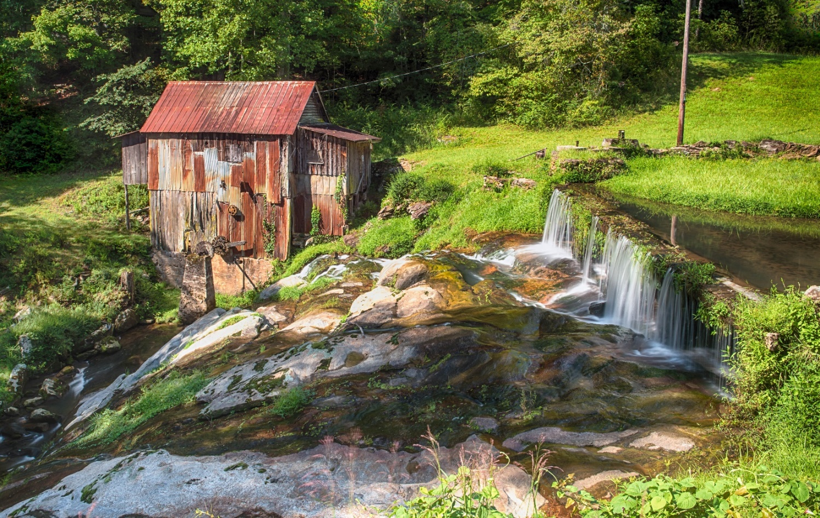

Description:
The little creek that powered the doesn’t seem to have a name but it’s a pretty spot
none-the-less. The consensus is that the mill was built in the 1930’s and produced flour
from corn until it ground to a halt in the mid-1960’s. The millrace and water wheel are
gone but the millpond dam (although the pond is silted in) is still there.
Notes for the photographer:
You will want to photograph the mill in the morning to avoid having the mill building in
shadow. The mill is on private property, but the best view is from across the creek on
the public roadway.
Directions: From the traffic signal in Clarkesville, travel westward 4.1 miles on State
Road 115 to a left turn onto Pardue Mill Road. The mill is one-half mile on the right.
Park before crossing the bridge.
Coordinates for the mill: 34°35&#39;34.8 & quot;N 83°35&#39;08.0&quot;W
Interesting fact: This little picture shows the millrace and the wheel. Standing in front is
the original owner and his wife. Picture made in 1945.

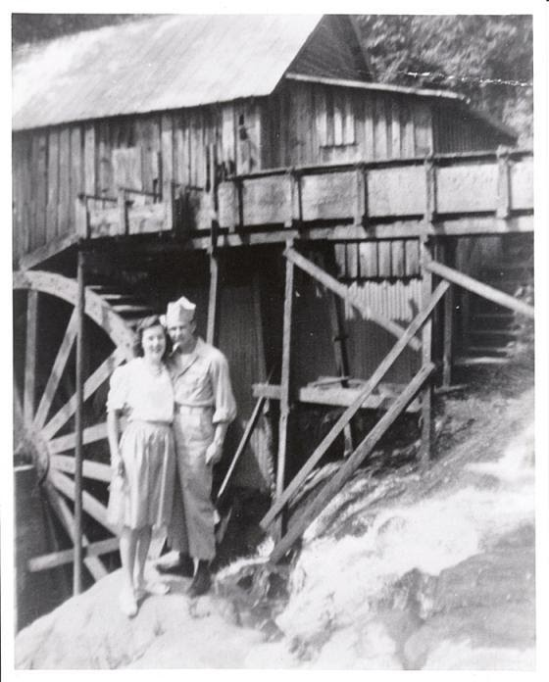

Member spotlight: John Martin, Foothills Founder

Born and raised where?
Born in Miami and spent my early (pre-work) life there.
Education
Earned a BS in electrical engineering from Clemson and an MBA in management
from the University of Miami.
Work experience
My first job out of college was with General Electric. Moved around to five
different locations while with GE. Left GE and moved to Habersham County to
gain the good life. It worked. I was the Director of Engineering at Habersham
Medical Center for fifteen years. Retired from HMC fourteen years ago.
Early family life: parents worked where, etc.
My dad was an electrician. His work kept him in Miami with the exception of
contract work with the Navy in Key West and the government at Oak Ridge,
Tennessee. Mom did secretarial work.
Current family life:
I’m married to Phoebe (56 years) but, unfortunately, she has advanced
Alzheimer’s Disease and for the past two years has been living in an assisted
living facility. Our two children live in Clarkesville and Auburn with their families.
We have five grandchildren.
First interest in photography
I became interested in photography while working for GE. I was involved to the
point of developing my own film and making my own prints.
Summary of your journey on the photography highway
I dabbled with photography for many years – primarily in making slides. When
digital came along I digitized all 6,000 slides that I had accumulated. Now my
computer contains over 45,000 images – most of which were made while
traveling to over 36 countries.
The part of photography you like the most

Learning. Seems there is always something new in photography – and there is
always the challenge of making better images.
Landscapes, cultural images – these are the things that feed my wanderlust.
Travel and photography go hand in glove for me.
What are some of your photography goals?
I want to learn more about using Photoshop, I want to improve my processing of
black and white images, and I want to teach others the skills I’ve learned in
processing photos in Lightroom.
Accomplishments in photography you are most proud of
The founding of Foothills Photography Group has to be at the top of the list. I’m
also proud of being invited to address the annual conferences of The
Photographic Society of America in Spokane, Salt Lake and San Antonio.

Opportunities & Contests: (special things to do during quarantine)

NEED A MENTOR? WANT TO LEARN SOMETHING NEW? John Martin submitted a few thoughts and shows us how this works:
Stuck at home? Of course, you are. But that doesn’t mean that you are out of reach for on-line
mentoring. It’s easy. Here is how it works.
First, the mentor opens up a Zoom meeting. It’s free and the time allowance for a one-on-one meeting
is unlimited. He/she then invites the mentee to join at a set time convenient to both. For more info,
check here: https://support.zoom.us/hc/en-us/articles/201362613-How-Do-I-Host-A-Video-Meeting-
The meeting opens and the mentor taps the “share screen” icon. Magically, both the mentor and the
mentee are seeing the mentor’s screen – where he has previously opened Lightroom (or whatever
program is the subject of the mentoring session). For more info, look here:
https://support.zoom.us/hc/en-us/articles/201362153-Sharing-your-screen
And finally, the mentor places a phone call to the mentee. The mentor/mentee phone call handles all
the voice communication for the mentoring session.
It’s easy, and it works.
If you want to do something useful while not getting out in the (still) infectious world, give Chuck Lotts a
call at call at 404-452-0976 or drop him an email at catandchuck@windstream.net. He has a list of the
mentors and their specialties – he’ll match you up with a mentor and help you get started.

Contest submitted by Ashley Farmer: https://psa-photo.org/index.php?clubs-councils/newsletter-contest

The Professional Photographers of America (PPA) has opened their online classes to everyone. FOR FREE! These classes – 1,100 of them! – can be accessed here: https://www.dpreview.com/news/9935972902/ppa-offering-free-access-1100-classes-amidst-covid-19-quarantines. You’ll be asked to set up a free account, but no charges made.

And that’s not all. Scott Kelby has opened 480 webinars; also, FOR FREE. The first one on the list is “10 things photographers can do while stuck indoors”. You’ll be asked to open an account – but no charges. Here is the link: Webcasts – KelbyOne (thanks for the submission John)

Group Fieldtrips:

May 16th 10 am at Gibbs Gardens. Looking at the bloom calendar, there will be large numbers of plants and flowers blooming. This is a good social distancing trip!

The June trip is tentatively set for June 6th at the NE Georgia Swap Meet. It looks interesting due to the large number of item that people are selling which should make for some interesting shots. More information coming soon.

Upcoming group trips to calendar: (more information coming soon)
Sept 6 & 7 Rodeo
Sept 12 Dragon boat races
Oct 24 & 25 Air show

Foothills Photography Group News:

May meeting will be on Zoom. All paid members will be sent an invitation to view the meeting. You will be able to view from your phone, tablet or computer.
(Meetings are usually at North Georgia Technical College (NGTC) in the Visual Tech Building, Clarkesville Campus. Social Time begins at 6:30 PM and meeting at 7:00 PM. Look for signs as you approach the college from Clarkesville.)
